Chapter 5, Solution 72.

Find the load voltage v_{L} in the circuit of Fig. 5.98.

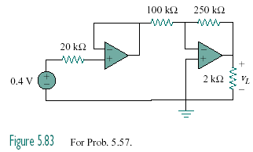

1.8 V

Figure 5.98
For Prob. 5.72.

Solution

Since no current flows into the input terminals of ideal op amp, there is no voltage drop across the 20 kΩ resistor. As a voltage summer, the output of the first op amp is
v₀₁ = 1.8 V

The second stage is an inverter

–4.5 V.

